SCHOOL OF COMPUTER SCIENCE AND ARTIFICIAL INTELLIGENCE |  |  |  |  | DEPARTMENTOF COMPUTER SCIENCE ENGINEERING
ProgramName:M. Tech/MCA/MSC |  |  |  | AssignmentType: Lab |  |  | AcademicYear:2025-2026
CourseCoordinatorName |  |  |  | Venkataramana Veeramsetty
CourseCode |  |  |  | CourseTitle |  | AI Assisted Problem Solving Using Python
DateandDay  of Assignment |  |  | Week5- Monday | Time(s)
AssignmentNumber:11.3(Presentassignmentnumber)/24(Totalnumberofassignments)
NAME: RIMSHA MUJEEB
ROLLNUMBER:2503B05138
 | Q.No. | Question
 | Q1.  Q2.  Q3.  Q4. | Task Description #1 – Stack class implementation  Task: Ask AI to implement a stack class with push(), pop(), peek() and is_empty() methods  PROMPT:  “Implement a Python Stack class with the methods push(), pop(), peek(), and is_empty(). The class should follow proper naming, handle errors safely, and use an internal list to store stack elements."  CODE:  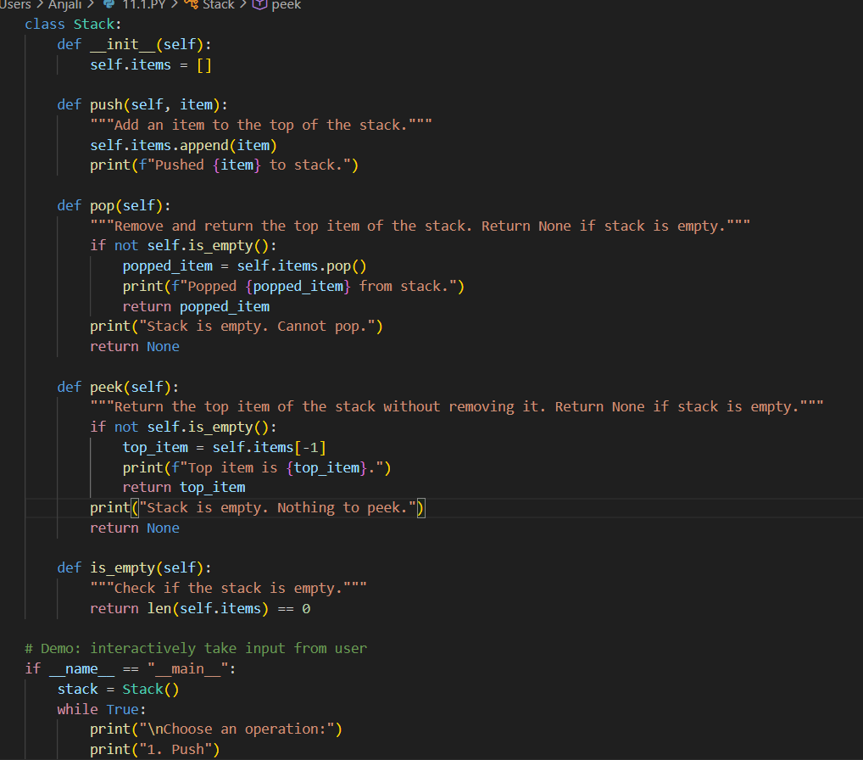  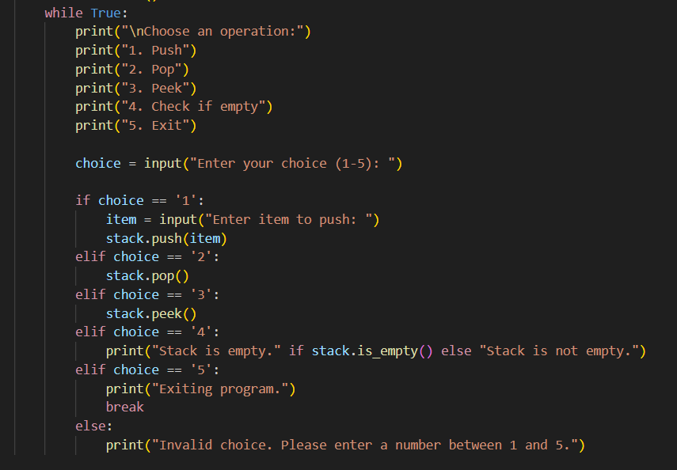  OUTPUT:  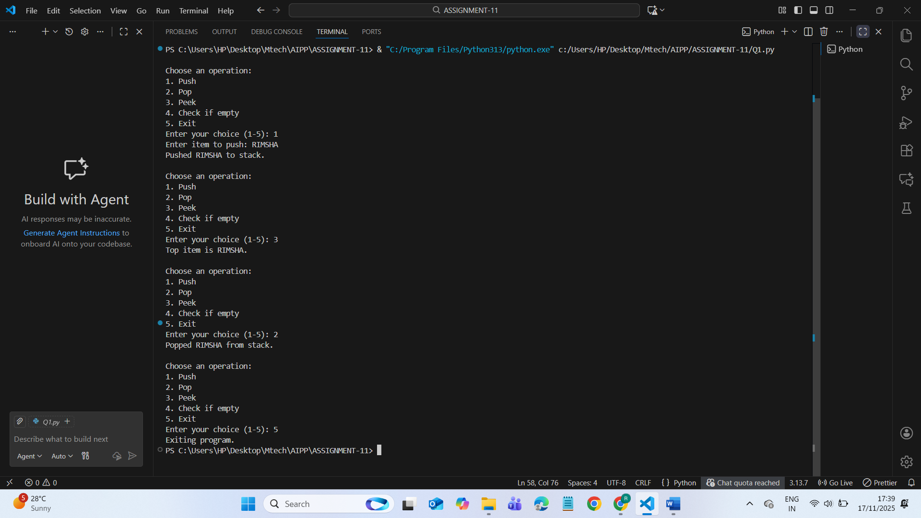  Task Description #2 – Queue Implementation  Task: Use AI to generate a Queue class with enqueue(), dequeue(), and is_empty().  PROMPT:  "Implement a Python Queue class with enqueue(), dequeue(), and is_empty() methods. Use a list or deque internally and write clean, readable code."  CODE:  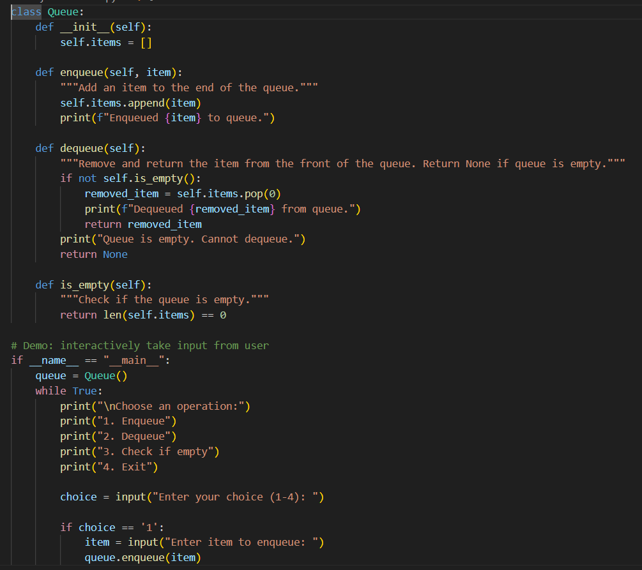  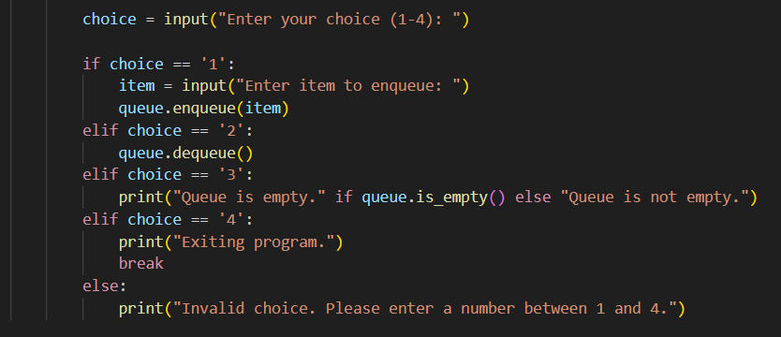  OUTPUT:  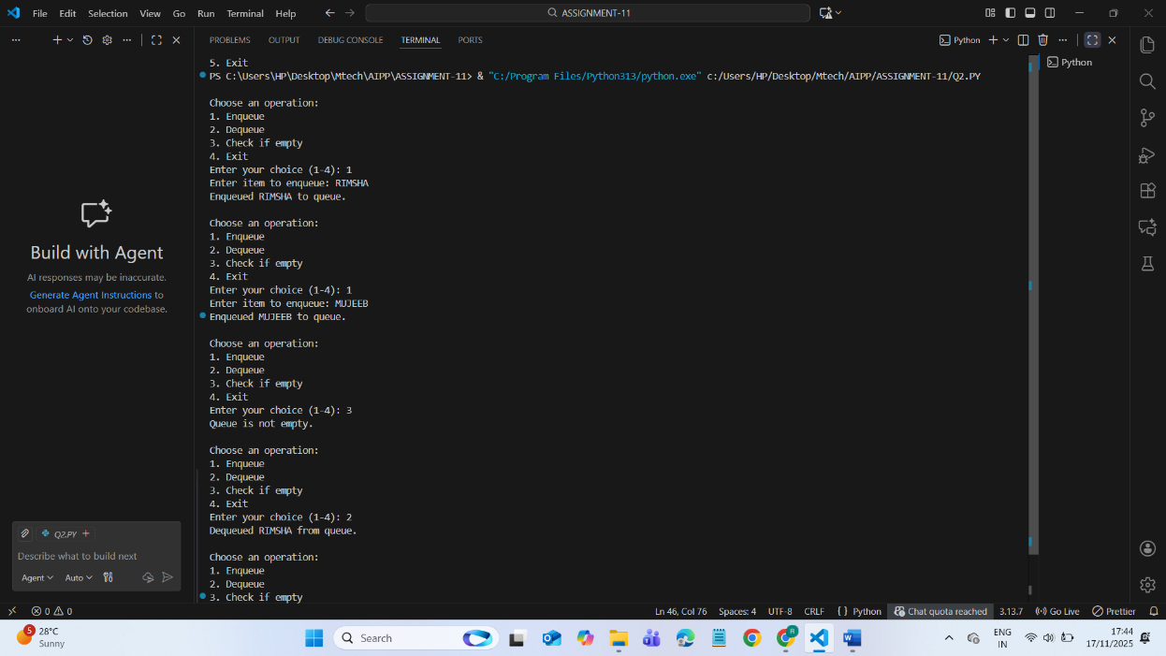  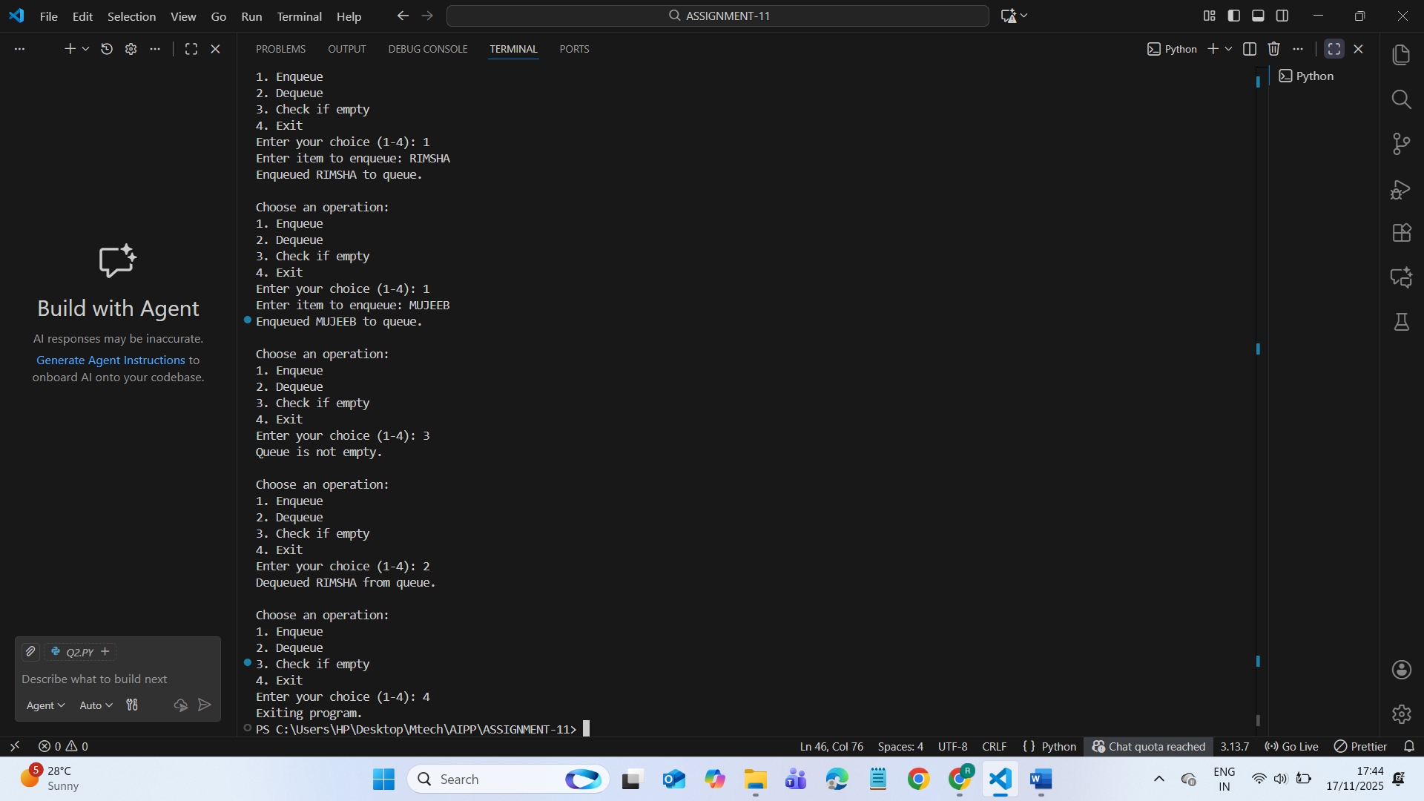  Task Description #3 – Linked List Implementation  Task: Ask AI to create a singly linked list with insert_at_end(), insert_at_beginning(), and display().  PROMPT:  "Implement a singly linked list in Python with the methods insert_at_end(), insert_at_beginning(), and display(). Use a Node class and ensure the code is clean and readable."  CODE:  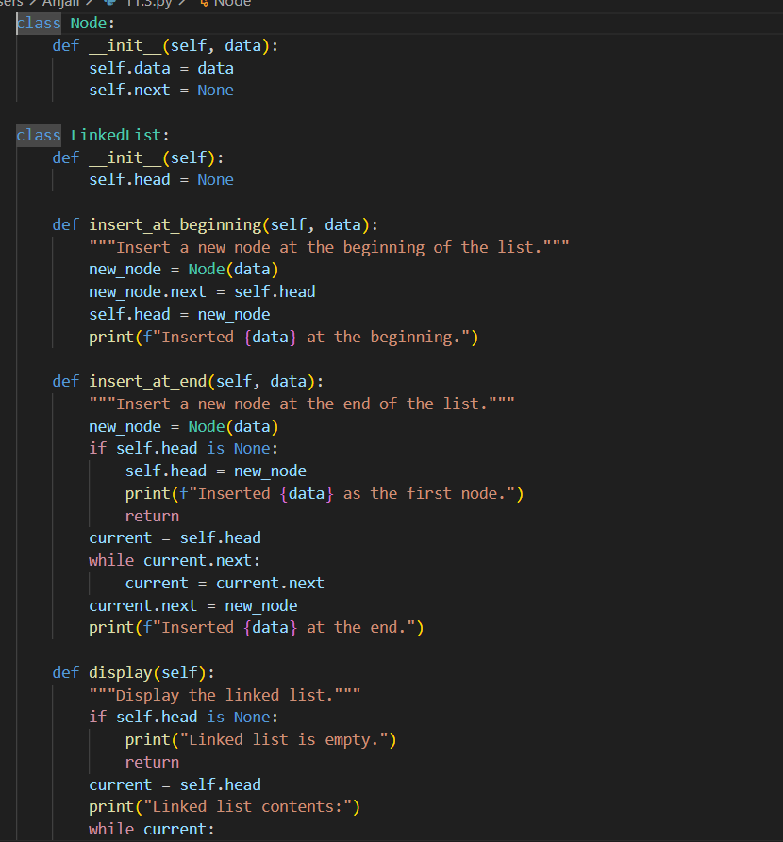  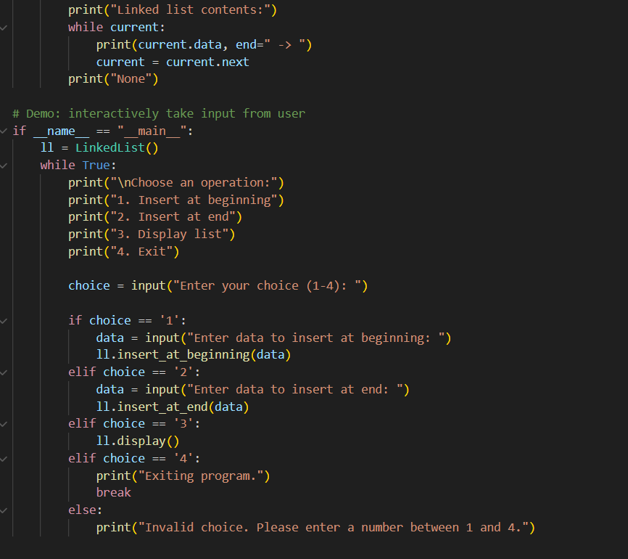  OUTPUT:  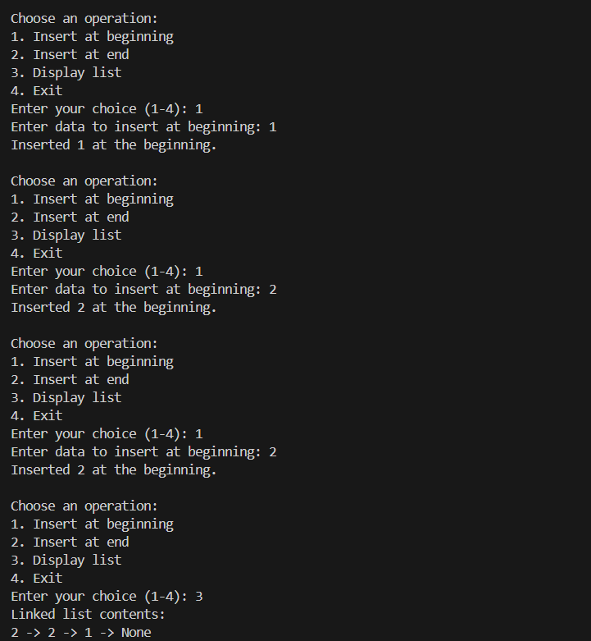  Task Description #4 – Binary Search Tree (BST)  Task: Ask AI to generate a simple BST with insert() and inorder_traversal().  PROMPT:  "Implement a Binary Search Tree (BST) in Python with insert() and inorder_traversal() methods. Use a Node class and follow clean coding practices."  CODE:  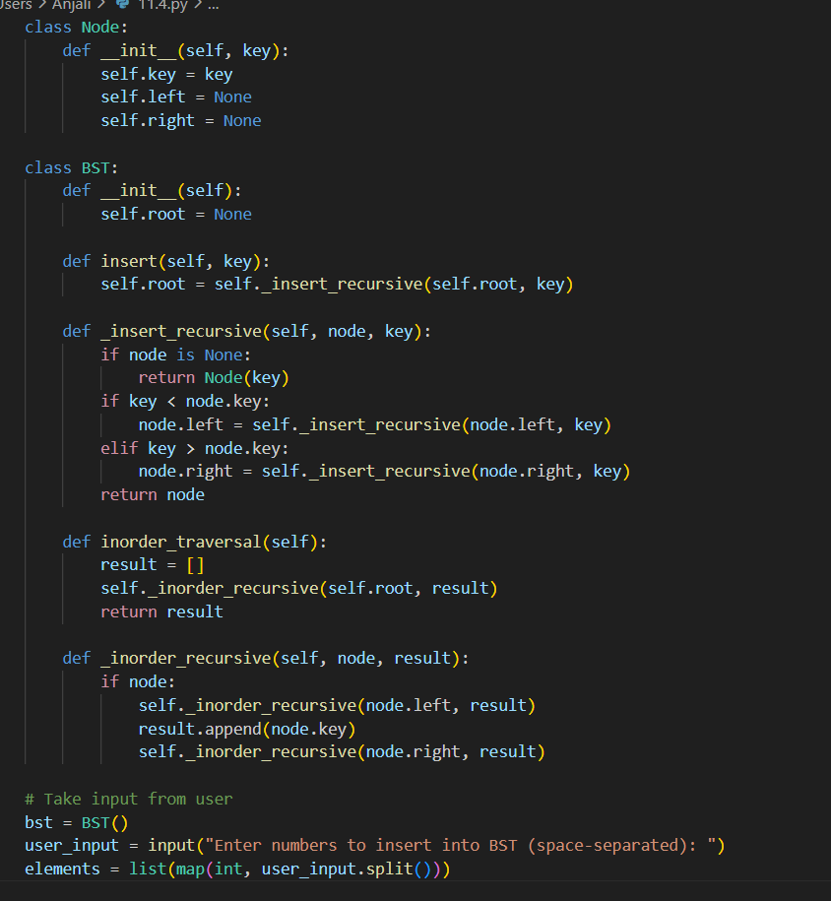  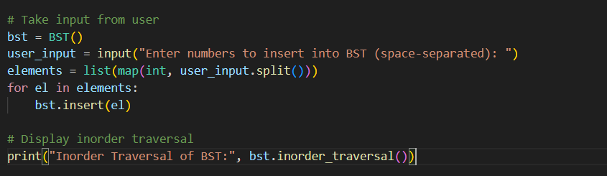  OUTPUT:  